Assignment-15.6: Build and Deploy Hadoop word count program using Gradle

I am creating a Folder named **Hadoop_app_gradle** and inside the **src/main/java** directory, I am writing the Wordcount program

Gradle Build Command:

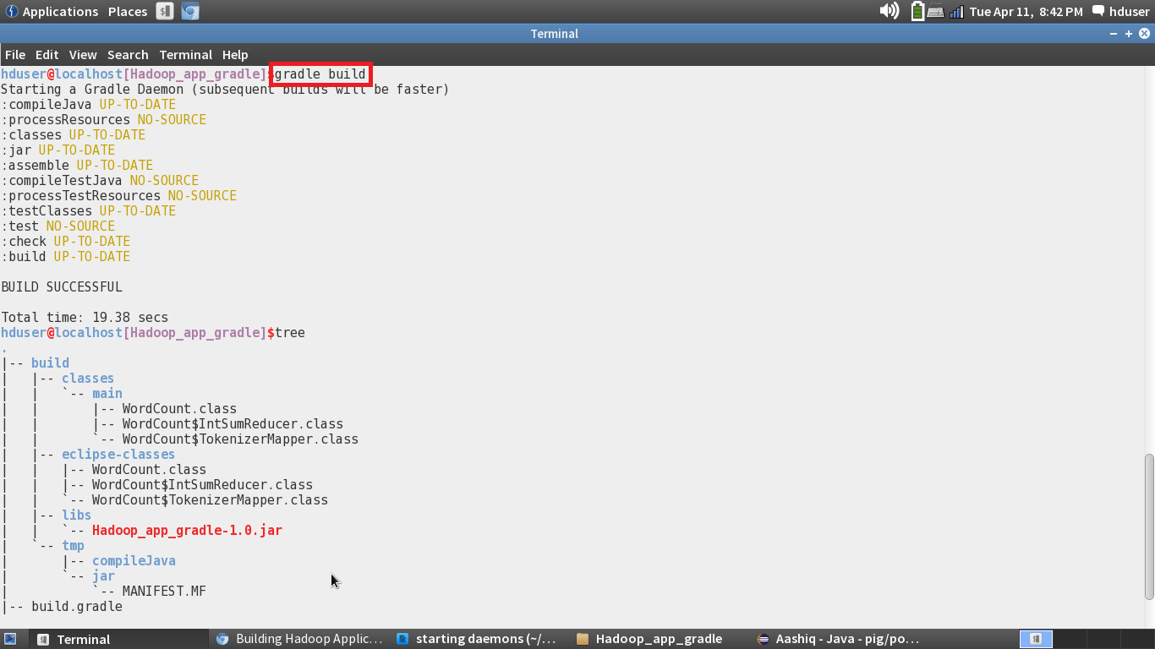

Building the Project using the Gradle eclipse Command:

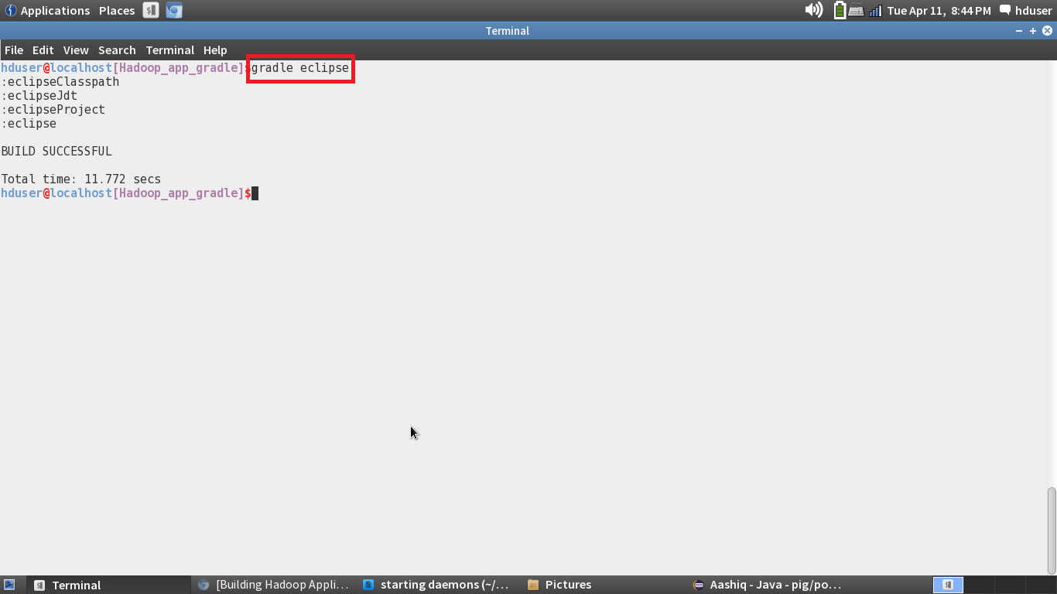

Importing the project into the eclipse:

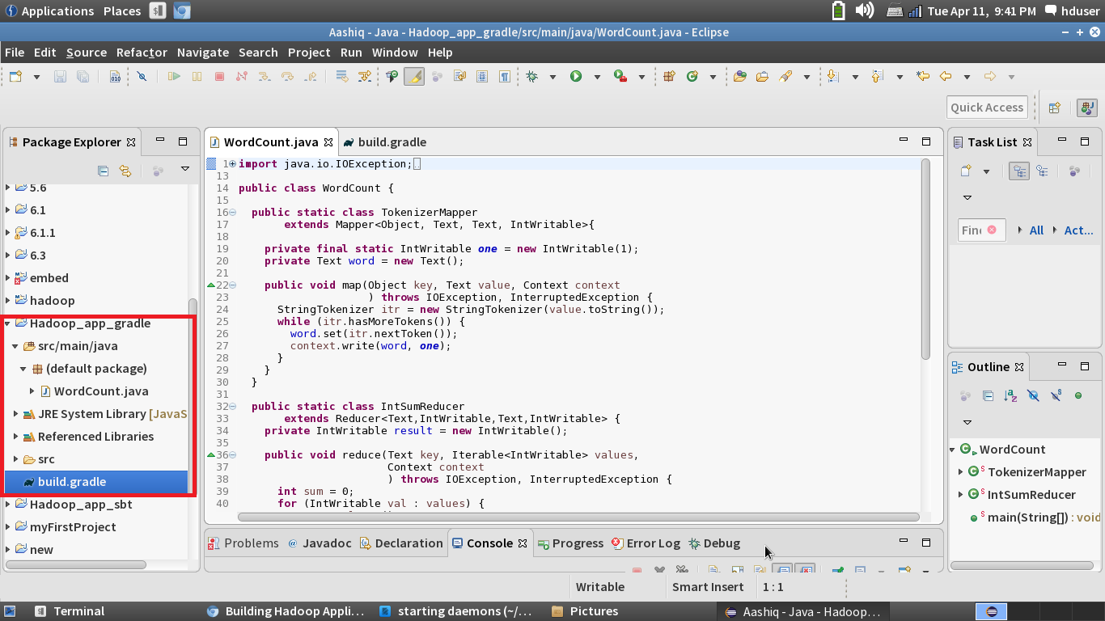

Jar Created in the target folder:

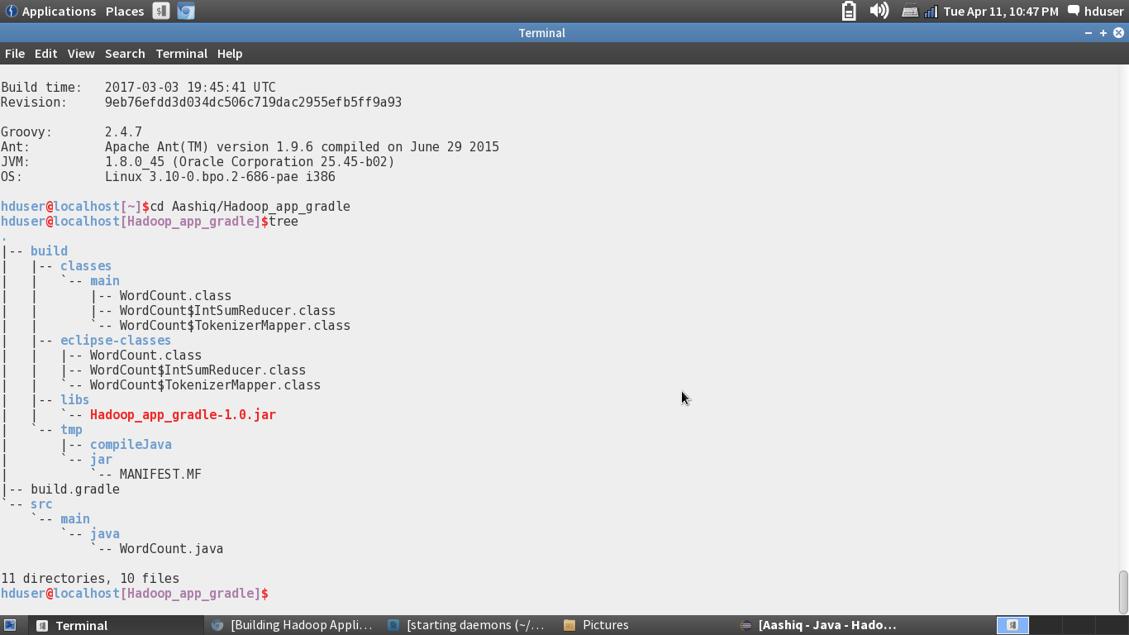

Running the Jar File:

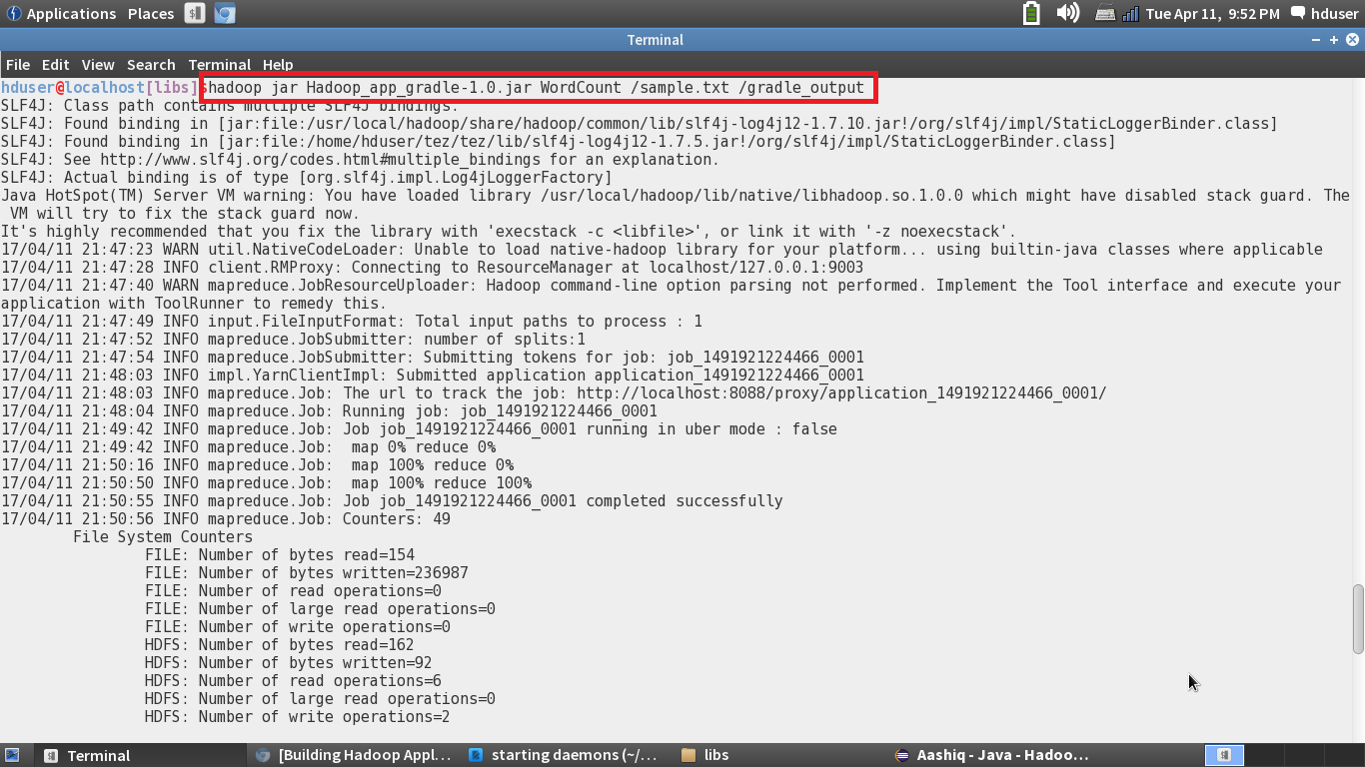

Output:

